LLETZ procedure
Vaginal excision
Discharge Instructions

- Rest at home today and gradually increase your activity as tolerated. Do not drive a car or sign any legal documents today. Have someone drive you home.

- Please refrain from sexual intercourse for 4 weeks.

- You may shower using soap and water as desired but avoid baths for 4 weeks.

- Use a pad for bleeding. Do not use tampons or douches. You may have some light bleeding or spotting for as long as two weeks. One of the most likely times to experience bleeding complications after this procedure is from 8 to 14 days after your surgery. If, at any time, the bleeding becomes abnormally heavy (saturating one pad repeatedly every 15 minutes) please call Dr. Nascimento on pager 07 56765036.

- Occasionally, there is a yellow to bloody water discharge, or a dark brown dirt-like discharge. This is normal and should be controlled with a pad.

- Pain management at home: take Panadol 1g every 6 hours as required.

- Disturbed menstrual pattern is common. If you are taking the oral contraceptive pill you should continue to take it as usual.

- Please refrain from heavy lifting or vigorous exercising (aerobics, calisthenics, weight lifting) for 2 weeks.

- You may notice a small piece of absorbable knitted fabric coming out of the vagina. This is normal; it is used to prevent vaginal bleeding.

- Reports from biopsies and final histopathology specimens will be received by Dr. Nascimento within 5 to 7 working days. Dr Nascimento will contact you with the results or discuss them with you on your follow-up visit.

Contact Dr. Nascimento (Pager 07 56765036) at any time if you experience:
- Bleeding heavier than a period.
- Severe abdominal or back/flank pain, severe nausea or vomiting, or shaking chills.
- Fever over 38°C.
- Burning on urination or inability to urinate.
- Foul-smelling discharge that persists for more than 3 days.
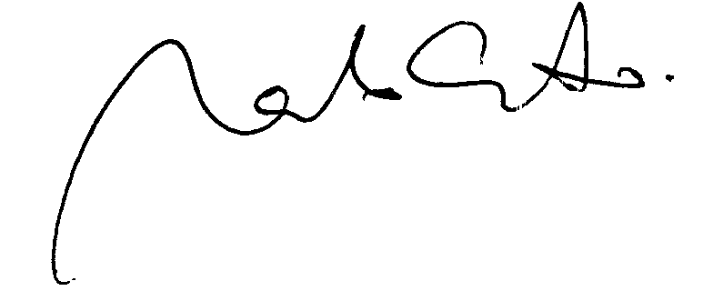
Dr. Marcelo Nascimento

