Diagnostic Laparoscopy
Discharge Instructions

Medication:
- Resume your preoperative routine medications.
- Take your pain medications and/or antibiotic as explained to you by our nurses.

Constipation:
- Some changes in your bowels are normal following any surgery including constipation. To prevent this, drink 6-8 glasses of fluids per day, eat high fibre foods, prunes, etc. Metamucil or Coloxyl & Senna are okay. Call during office hours if these methods are ineffective.

Wound Care:
- You have “glue dressings”, they will peel off in a few days, you can wash and dry normally.
- It will take up to 6 months for your incision to mature into its final form. Ridges and raised red scars will diminish in time and smooth out.
- Notify your local doctor or call our rooms if the wound becomes red, irritated, or purulent discharge develops. A small amount of blood or clear discharge is normal initially.
- Some mild abdominal distention and/or cramping are normal. Occasionally, patients report right shoulder pain. A warm heating pad and walking should relieve the discomfort.

Activity:
- After surgery, take it easy for a couple of days before resuming your normal routine.
- No driving at the day of your surgery.
- There are no restrictions with regards to heavy lifting.
- It is important to be up and out of bed, walking, but you may fatigue easily and it is important to get enough rest.
- There is no limit to stair climbing.

Normal Post-Op Changes:
- You may feel bloated for a few days following your surgery. This will improve with activity.
- Some abdominal bruising is normal, as is drainage and small bleeding from your incisions.
- Vaginal bleeding and discharge are normal for up to 6 weeks if you had any uterine manipulation during your procedure.

Follow-up:
- If not already scheduled, please call our office at your earliest convenience to make an appointment for 2 weeks after your surgery: 07 55645110.
- Reports from biopsies and final histopathology specimens will be received by Dr. Nascimento within 5 to 7 working days. Dr Nascimento will contact you with the results or discuss them with you on your follow-up visit.

Contact Dr. Nascimento (Pager 07 56765036) at any time if you experience:
- Bleeding heavier than a period.
- Severe abdominal or back/flank pain, severe nausea or vomiting, or shaking chills.
- Fever over 38°C.
- Burning on urination or inability to urinate.

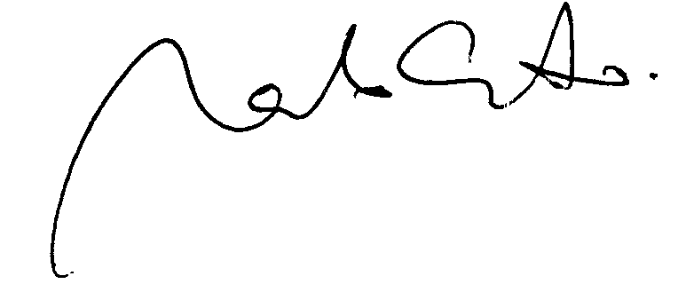
Dr. Marcelo Nascimento

