Vulval radical excision
Discharge Instructions

- Rest at home today and gradually increase your activity as tolerated. Do not drive a car or sign any legal documents today. Have someone drive you home.

- Please refrain from sexual intercourse for 4 weeks.

- You may shower using plain soap and water as desired but avoid baths for 2 weeks after your procedure.

- Use a pad for bleeding. Do not use tampons or douches. You may have some light bleeding or spotting for as long as two weeks.

- Occasionally, there is a yellow to bloody water discharge, or a dark brown dirt-like discharge. This is normal and should be controlled with a pad.

- Pain management at home: take Panadol 1g every 6 hours as required.

- Please refrain from heavy lifting or vigorous exercising (aerobics, calisthenics, weight lifting) for 1 week.

- Apply Dalacin V (local antibiotic) to the wound(s) twice a day for the next 5 days.

- Reports from biopsies and final histopathology specimens will be received by Dr. Nascimento within 5 to 7 working days. Dr Nascimento will contact you with the results or discuss them with you on your follow-up visit.

Contact Dr. Nascimento (Pager 07 56765036) at any time if you experience:
- Bleeding heavier than a period.
- Fever over 38°C.
- Burning on urination or inability to urinate.
- Foul-smelling discharge that persists for more than 3 days.

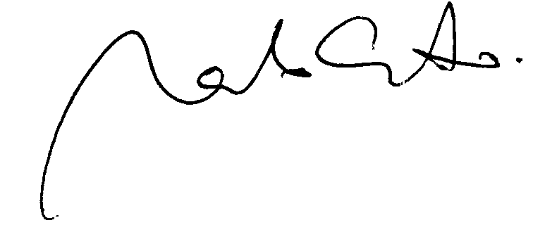
Dr. Marcelo Nascimento

